**Statistical Data Analysis**

**By Harsh Kapoor**

**8th May 2022**

**Statistical Data Analysis**

Statistical data analysis is a procedure of performing various statistical operations. It is a kind of quantitative research, which seeks to quantify the data, and typically, applies some form of statistical analysis. Quantitative data basically involves descriptive data, such as survey data and observational data.

**Statistical Tools for Data Analysis**

* The Mean
* Median and Mode
* Range & Dispersion
* Standard Deviation
* Inter Quartile Range
* Coefficient of Variation (CV)
* Regression
* Hypothesis Testing

Statistics is a field of science concerned with gathering, organising, analysing, and extrapolating data from samples to the entire population.

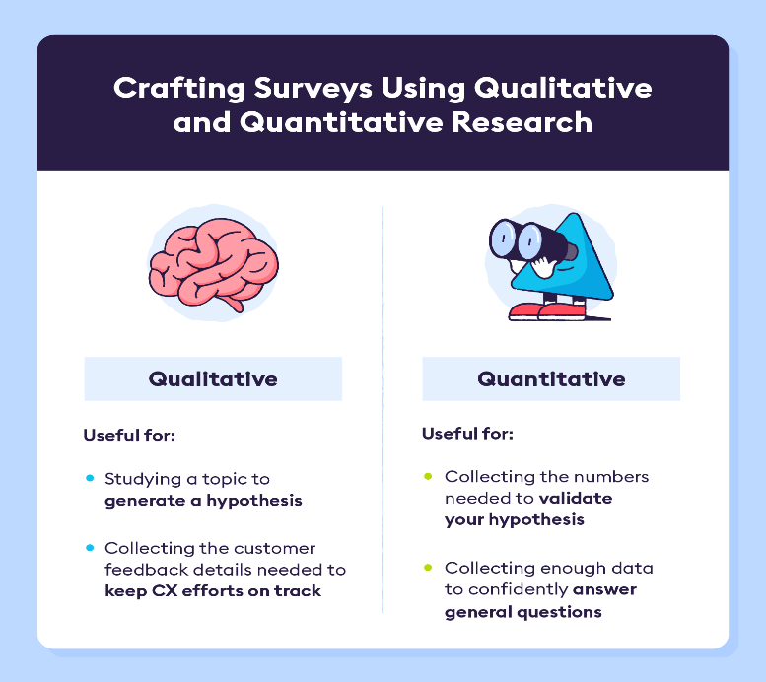

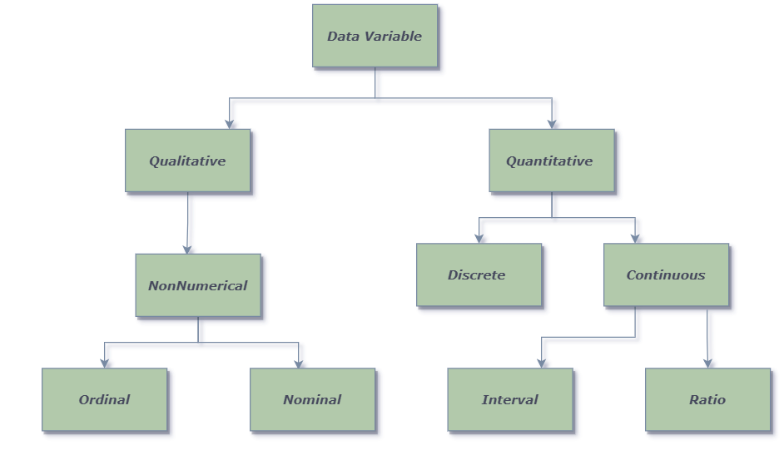

**Quantitative data is anything that can be counted or measured**, it refers to numerical data. How much, how many, how often. Analysed using statistical analysis. Usually, a large number of subjects who are randomly selected and represent the population of interest.

* Discrete – Countable, nothing in between, digital
* Continuous – infinite, always something between, analog
* Interval- Difference between measurements but no true zero, Temp in Fahrenheit etc.
* Ratio- Difference between measurements, true zero exists, Height, Age, etc.

**Qualitative data is descriptive**, referring to things that can be observed but not measured—such as colours or emotions. Describes certain “attributes” and helps us to understand the “why” or “how” behind certain behaviours. Analysed by grouping the data into meaningful themes or categories. Usually, a small number of non-representative cases.

* Non-Numerical
* Ordinal – ordered categories, student grades etc.
* Nominal- unordered categories, Marital status, Type of Car etc.

|  |  |
| --- | --- |
| **Quantitative Data** | **Qualitative Data** |
| **My best friend is 5 feet and 2 inches tall** | **My best friend has curly brown hair** |
| **They weigh 51 kilograms** | **They have brown eyes** |
| **They have two cats** | **My best friend drives a red car** |
| **They go swimming four times a week** | **My best friend is funny and a good listener** |

|  |  |  |  |  |  |
| --- | --- | --- | --- | --- | --- |
| **Scale** | **True Zero** | **Equal Intervals** | **Order** | **Category** | **Example** |
| **Nominal** | **No** | **No** | **No** | **Yes** | **Marital Status, Sex, Gender** |
| **Ordinal** | **No** | **No** | **Yes** | **Yes** | **Team Rankings, Student Grades** |
| **Interval** | **No** | **Yes** | **Yes** | **Yes** | **Temperature** |
| **Ratio** | **Yes** | **Yes** | **Yes** | **Yes** | **Age, Height Weight** |